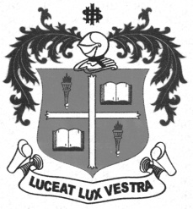
LOYOLA COLLEGE (AUTONOMOUS), CHENNAI – 600 034
B.A. DEGREE EXAMINATION – TAMIL LITERATURE
FIFTH SEMESTER – NOVEMBER 2012

TL 5505/3500 - EPICS & WORLD TAMIL LITERATURE

Date : 08/11/2012 Dept. No. Max. : 100 Marks
Time : 9:00 - 12:00



x = 
- 
- 
- 
- 
- 
- 
- 
- 
- 
- 



x = 
- 
- 
- 
- 
- 
- 
- 
- 
- 
- 



 x = 
- 



- 


- 


- 





